**Blackbox Testing: One-direction test**

**One-direction-1**

**East Green Street-S 6th Street, East John Street-S 6th Street**

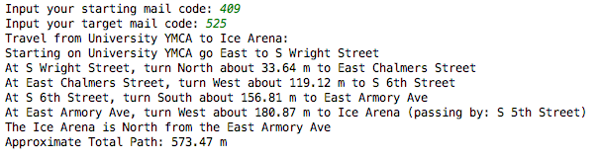

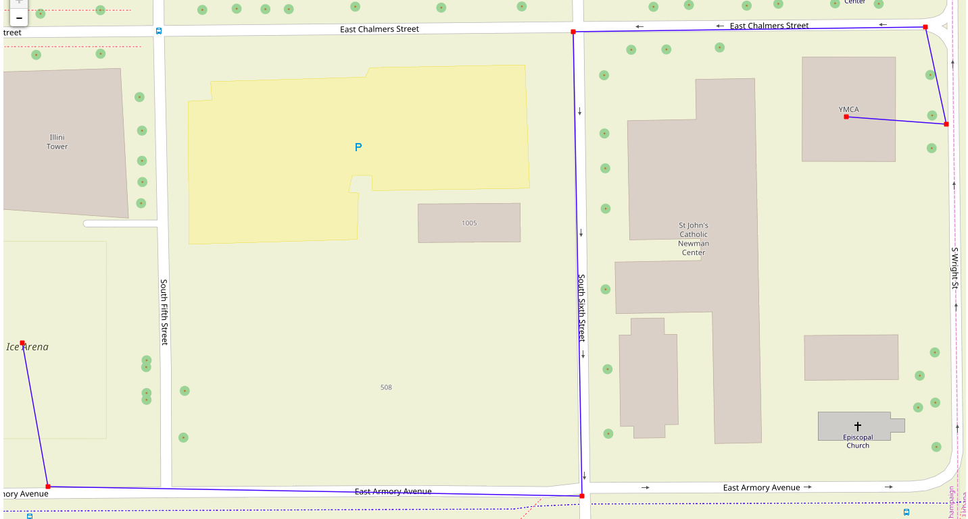

**One-direction-2**

**East John Street-S Wright Street, East John Street-S 6th**

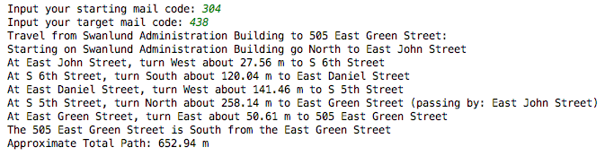

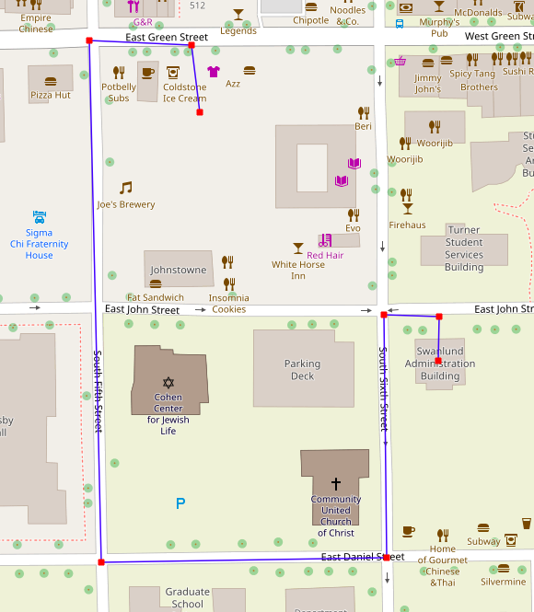

**One-direction-3**

**East John Street-S 5th Street, East John Street-S 6th Street**

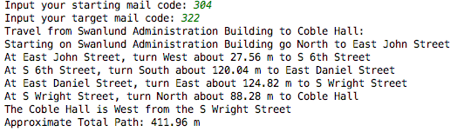

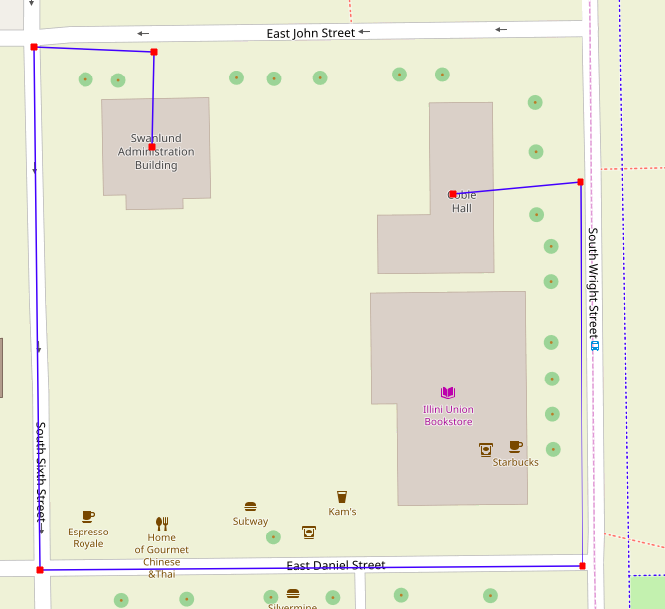

**One-direction-4**

**East Armory Ave-S Wright Street, S Wright Street-East Chalmers Street**

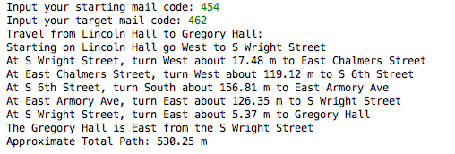

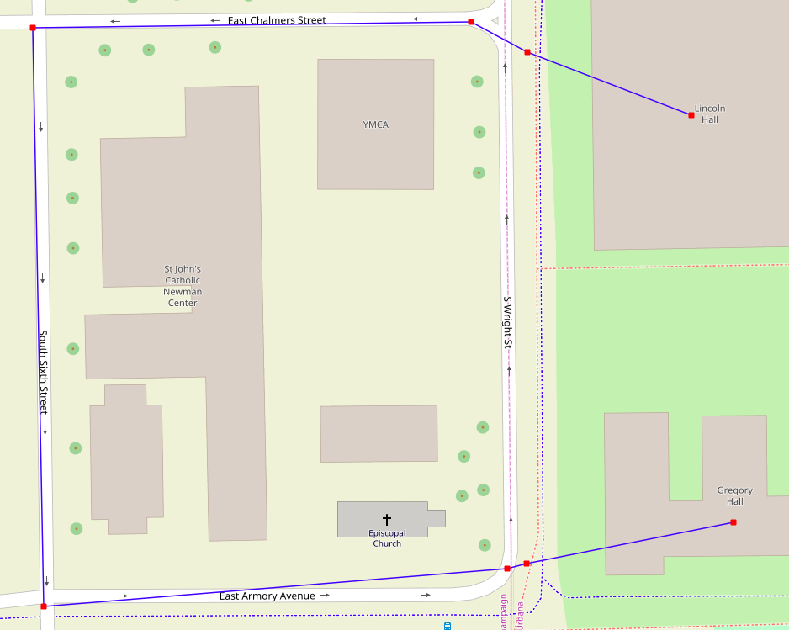

**One-direction-5**

**East Daniel Street-S Wright Street, S Wright Street-East Chalmers Street**

